REVIEW OF EXISTING SERVICE TUNNEL FOR CONSTRUCTION EQUIPMENT
AT CENTRAL SERVICES BUILDING
 | University of Waterloo  Review of Existing Service Tunnel for Construction Equipment at Central Services Building  Project No.: 2025-0892-10 | October 03, 2025

Background

WalterFedy was previously retained by the University of Waterloo (herein “the University”) to provide
restoration design services and construction field review for over 500m of underground service tunnels on
Campus from the Lyle Hallman Building, to the General Services Complex (GSC), and continuing down to
Chemistry 2. WalterFedy has further performed a number of structural load checks in various areas of the
service tunnel network on campus for heavy truck traffic and construction equipment and has provided recommendations for upgrading the structure and shoring where necessary.

It is our understanding that a construction project is currently under way in the area around the Central Services Building (CSB), the GSC, and the Energy Research Centre (ERC). To implement this construction work, the Contractor intends to cross a portion of the underground tunnel (Tunnel 1A at ERC) using a Dieci – ICARUS 55.17. WalterFedy has been engaged by the University to provide a quotation for structural engineering services to review the existing service tunnel for the weight of a loaded Dieci ICARUS 55.17 boom.

Documentation Reviewed
The following documentation forms the basis of WalterFedy’s review:
Structural Record Drawings: by Shore & Moffat and Partners
- Drawing S1: Foundation Plan, Sub-Station Service and Floor Framing Plan and Details and Tunnel Details (Central Services Building Project) Marked “As-Built” and dated November 5, 1965.
- Drawing TS1: Shaft and Tunnel Details (Tunnels at Central Services Building Project) Marked “As-Built” and dated March 14, 1967.

Equipment Cutsheet: provided by the University
- Dieci – ICARUS 55.17 (5450 kg Maximum capacity + 14000kg Self weight)

Findings

The record drawings indicate that the tunnel segments reviewed have variable width and roof slab composition. Thus, each tunnel segment has a different load-carrying capacity, which is summarized in Figure 1 below. We have found the following:

- The tunnels shown in Figure 1 are suitable to support the crossing of an unloaded Dieci – ICARUS 55.1 in any location, except the deteriorated tunnel location marked. (i.e. the equipment may drive over the tunnel while not holding a load).
- The north/south oriented tunnel (marked with a red cross hatch) that is directly adjacent to CSB is NOT suitable to support the crossing of a fully loaded Dieci – ICARUS 55.1. (i.e. the equipment cannot cross the tunnel while also carrying its load). See Note 4 below for specific exception.
- The east west oriented Tunnel T4 (marked in blue) is suitable to support the crossing of a fully loaded Dieci – ICARUS 55.1. . (i.e. the equipment may drive over the tunnel while holding its load).
- It is our understanding that it would be beneficial for the rear tires of the Dieci – ICARUS 55.1 to be within 10ft of the CSB building, which bears on the roof slab of the tunnel adjacent to CSB. The wheels would be offset by 2ft from the tunnel wall in this case. Provided that the rear wheels do not bear on the deteriorated portion of the tunnel, we have found that the tunnel can support the REAR WHEELS ONLY when placed at least 10ft from CSB. We recommend that traffic cones be placed to locate the area of deteriorated tunnel, and to mark a line 10ft off CSB with flag people to ensure the equipment does not overload this tunnel.

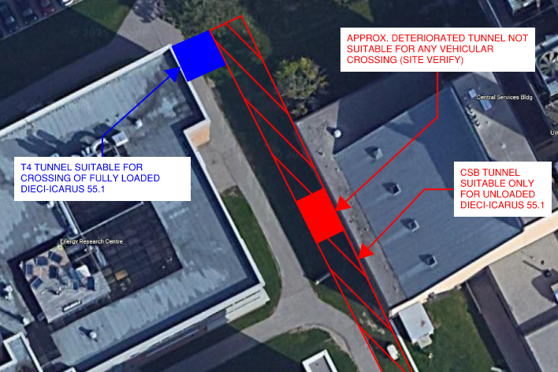

Figure 1: Area Reviewed and Findings Summary

If the work must be performed in a manner that the equipment must cross the north/south oriented tunnel adjacent to CSB while simultaneously carrying a load or deploying its outriggers, then temporary shoring would be required inside the tunnel.

We thank you for this opportunity to be of service, and we trust that the content of this letter is sufficient for your current needs. Please do not hesitate to contact the undersigned should you have any further questions, or if construction plans change that may require heavier equipment, and in turn temporary shoring.

Sincerely,

WALTERFEDY

Kyle Pellerin, P.Eng.
Structural Engineer, Associate
kpellerin@walterfedy.com
519.576.2150 Ext. 418

